Prerequisite IBM Cloud Service

|  |  |
| --- | --- |
| **Date** | 29 October 2022 |
| **Team ID** | PNT2022TMID37457 |
| **Project Name** | Project – Smart Farmer-IoT Enabled smart Farming Application |
| **Maximum Marks** | 4 Marks |

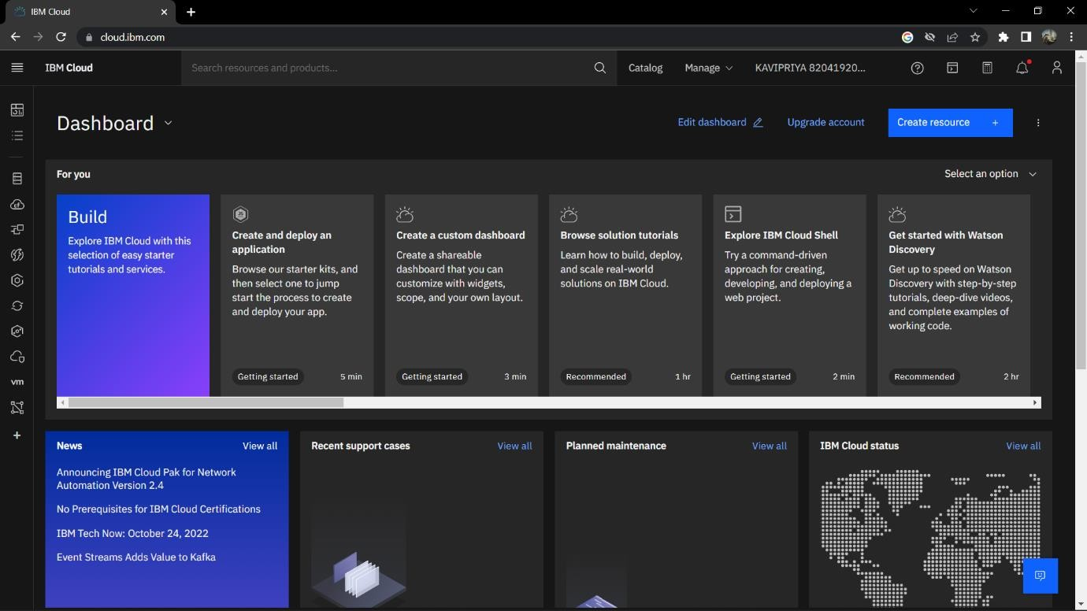IBM Account Dashboard

IBM Watson IoT Platform

